Parasitic Worms: Strongyloides Stercoralis AKA Thread worm

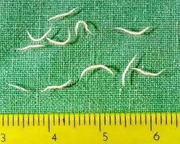

Natural Environment
- The thread worm lives in the soil where fecal water and soil is prevalent.

Region
- Normally found in tropical and subtropical climates such as Australia, Africa and Fiji

Reservoir
- Mainly soil, Dogs and Cats

Host Range
- Humans are host such as the cats and Dogs, if in contact Humans can be contaminated

Predisposing & Occupational Risks
- Walking barefoot
- Having Dogs or Cats with the worms

Disease
- Causes different phases of infections
- Cutaneous Phase: Slight hemorrhaging, swelling, ground itch
- Pulmonary Phase: Burning chest, coughing, wheezing, symptoms of bronchial pneumonia
- Intestinal Phase: aching in abdomen
- Occasionally septicemia
Infectious Dose- humans usually infected through contaminated soil containing L3 larvae.
- As little as 5-7 worms

Diagnosis: include eggs in feces , duodenal aspiration, ELISA
- Treatment: Albendazole, Thiabendazole
- Ivermectin more recently

Mode of transmission
- Directly touching disposal of human waste, soil contact that contains fecal water, petting dogs or cats that are carrying them, walking barefoot in contaminated soil

References
Bogitsh, B. J., C. E. Carter, and T. N. Oeltmann. 2013. Human Parasitology, 4th edition. Academic Press.
Dr.Russell Raymond, Professor of Parasitology
Government of Western Australia: Department of Health. Health Conditions: Threadworms. Retrieved from http://healthywa.wa.gov.au/Articles/S_T/Threadworms
NHS. (2015). Threadworms. Retrieved from https://www.nhs.uk/conditions/threadworms/

Parasitic Worms: Round Worm AKA Giant Intestinal Nematode

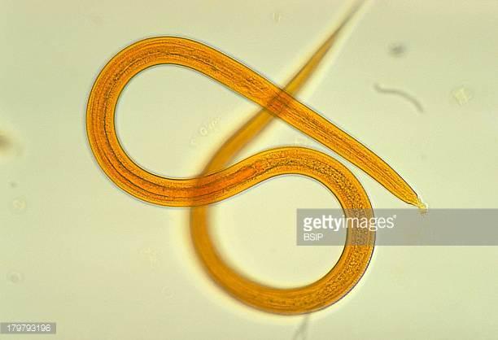
Ascaris lumbricoides

Natural environment:
Ascaris lumbricoides; Adults of Ascaris lumbricoides live in the lumen (space between or inside of two walls) of small intestine of either humans, pigs, or horses. Eggs live in feces, soil, small intestine. Hatchling lives in lumen of small intestine circulatory, and uses the lumen of circulatory system veins and arteries as transport, and lungs for transport.

Region where it can be found:
Ascaris lumbricoides: just about anywhere; in other words, in many different countries and cultures, does not discriminate.

Réservoir :
Ascaris lumbricoides: Ascaris lumbricoides thrives in lumen of small intestine, veins, and arteries and lung. Note to reiterate, it uses the circulatory system as a transport as a hatchling not necessarily as a reservoir.

Host Range:
Ascaris lumbricoides: found in humans in staggering amount; 2,000,000,000 (two billion) infections; however, this is mostly in children. Of this two billion, there are as many as 4 million people in the U.S infected.
-Ascaris Lumbricoides can also be found in infected pigs and horses whom contaminate the soil though defecation.

Predisposing & Occupational Risks:
Ascaris lumbricoides: Food contaminated with soil containing eggs, this is caused by feces containing the roundworm. Placing dirty fingers in the mouth that were in contact of contaminated soil, this is mostly seen in children with this issue.
-Areas of a lot of pigs and horses may have infections and are great transporters of the roundworm since they defecate constantly; persons whom work with such animals much take extra precaution.

Disease:
Ascaris lumbricoides: 85 percent asymptomatic (showing no signs of symptoms); 15 percent show infections. From this 15 percent, the most common symptom that alludes to Ascaris lumbricoides infection is upper intestinal discomfort.

Diseases caused by infection of Ascaris Lumbricoides range from allergies, intestinal blockage, malnourishment, or fatal Pneumonitis (alveoli become inflamed and flooded with fluid, which leads to dry drowning since the exchange of gases, CO2 and O2 cannot be completed, and the body fills with CO2, which is bad for the body if it is in excess).
Infectious Dose:

Mode of transmission:
Ascaris lumbricoides: ingesting soil that contains eggs. Eggs come from feces, where the round worm in the small intestine lives and eats and makes the eggs that pass-through stools. Prevalent in children, who are great mode of transmission since they constantly putting their fingers in the mouth everywhere they go. Very important to wash fruits and vegetables that were fertilized by manure; this is essential since manure may be mixed with infected soil.

Prevention as listed by the CDC:
- Avoid ingesting soil that may be contaminated with human feces, including where human fecal matter ("night soil") or wastewater is used to fertilize crops.
- Wash your hands with soap and warm water before handling food.
- Teach children the importance of washing hands to prevent infection.
- Wash, peel, or cook all raw vegetables and fruits before eating, particularly those that have been grown in soil that has been fertilized with manure
References:
Bogitsh, B. J., C. E. Carter, and T. N. Oeltmann. 2013. Human Parasitology, 4th
Edition. Academic Press.

Dr.Russell Raymond, Professor of Parasitology

Global Health- Division of Parasitic Disease. (2013). Parasites- Ascariasis Prevention and
Control. Retrieved from https://www.cdc.gov/parasites/ascariasis/prevent.html

Parasitic Worms: Hookworm


Ancylostoma duodenale
Necator americanus
Ancylostoma celanicum

Morphologically distinguished by their bent mouths and bent anterior ends.

Natural Environment / Reservoir:

- Exist primarily in warm moist climates with average temperatures between
20°C- 30°C
- Rain fall averages must be more than 40 in/yr
- Cannot survive in gravely, clay rich, or severely compacted soil. Must be of a sandy or loamy composition

* These conditions must exist for eggs to hatch*

- After hatching the larvae will typically live in the soil for a few weeks and then die almost immediately after exposure to direct sunlight or desiccation.

Region Where it can be Found:
- Necator americanus is the most common form of hookworm infection found in humans.
Primarily found in the Americas, Sub-Saharan Africa, Asia, and Australia. Most infected individuals concentrated in Sub-Saharan Africa & East Asia/ Pacific Islands.
- Ancylostoma duodenale predominant in the Middle East, North Africa, and Southern Europe
- Ancylostoma celanicum infection primarily concentrated in India, Asia, and Pacific Islands.

Host Range:
Parasite species | Hosts | Geographic distribution
Necator americanus | humans | Africa, India, Asia, China, central America
Ancylostoma duodenale | humans | Europe, Africa, India, China, Asia, patchy distribution in North and South America
Ancylostoma celanicum | cats, dogs, humans | Sri Lanka, India, Asia, Philippines

- Necator americanus (new world hookworm) and Aneylostoma duodenale (old world
- hookworm) are species specific to human infections.
- Infections have been reported in mammalian species in tropical/subtropical regions
- Hookworms that occur in carnivores, such as A. celanicum, are similar enough to human hookworms that they can partially develop in humans.
-A. caninum (dog hookworm) can almost complete its development.

Predisposing & Occupational Risks/ Disease/ Infectious Dose:

- Living in poverty stricken regions with poor sanitation is always a risk (e.g. Infection most concentrated among the world’s poorest who live on less than $2 a day).
- Walking barefooted on soil in these regions increases risk of infection.
- Infection commonly found in miners and tunnel builders, due to soil exposure.
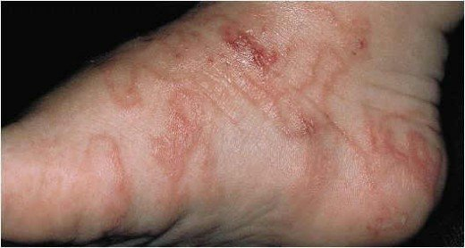
- Diseases
  - Hookworm disease
  - Anemia (possible)
Infectious Dose
  - As little as 10 worms, possibly less

Mode of Transmission, Symptoms, and Treatment
- Transmission
  - Walking barefoot on contaminated soil
    - Entry through skin, passage into the bloodstream, then the lungs, next the windpipe, and then swallowed and carried down into the small intestine.
- Symptoms
  - Infection, “ground itch”
  - Diarrhea
  - Abdominal pain
  - Cramps
  - Nausea

- Treatment(s)
  - Depending upon results of fecal test, treatment for anemia may be administered
  - Hookworm disease
    - Mebendazole or albendazole may be prescribed
    - Iron supplement may also be prescribed

Prevention
- Wearing shoes outside
- Drinking potable water
- Proper food handling techniques
- Handwashing

References:
Cleveland Clinic. (2016). Hookworm Disease. Retrieved from
https://my.clevelandclinic.org/health/articles/hookworm-disease

Delgado, A. (2016). Hookworm Infection. Retrieved from
https://www.healthline.com/health/hookworm#overview1

Global Health- Davison of Parasitic Diseases and Malaria.; (2016). Hookworm. Retrieved from
https://www.cdc.gov/dpdx/hookworm/index.html

Makama, F. (2014). Hookworm Infection (Ancylostomiasis): Morphology, Life Cycle And
Clinical Presentations. Retrieved from https://hubpages.com/health/Hookworm-Infection-Ancylostomiasis-Morphology-Life-Cycle-And-Clinical-Presentations

Mortimer, K., et al. (2006). Dose-ranging study for trials of therapeutic infection with Necator americanus in humans. Retrieved from https://www.ncbi.nlm.nih.gov/pubmed/17123987

Parasite Info. (2010). Hookworm. Retrieved from
http://www.parasiteinfo.com/parasites/hookworm.htm

Parasitic Worms: Whipworm (Trichuris trichura)
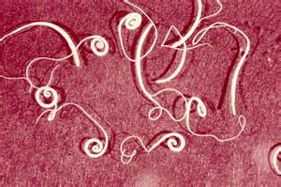

Natural Environment:
- Eggs can live in an environment anywhere from a few months to years
- More common in warm moist climates (humid)
- Thrive in shaded environment but can be found in sunny climate.
Region where it can be found:
- Cosmopolitan- familiar with and at ease in many different countries and cultures
- Worldwide (chiefly tropical, especially in Asia and, to a lesser degree, in Africa and South America. Within the United States, infection is rare overall but may be common in the rural Southeast)
Reservoir:
- Found in rectum, appendix, colon, and Large intestine (live mainly in the intestine)
- Life cycle-
- Eggs are deposited from human feces to soil where, after two to three weeks, they become embryonated and enter the “infective” stage.
- The life cycle from time of ingestion of eggs to development of mature worms takes approximately three months.
- The female T. trichiura begin to lay eggs after three months of maturity. Worms commonly live about 1 year (lay up to 20,000 eggs per day)
Host Range:
- Animals (dogs, cats, pigs etc.), and humans
- Different species of whipworms infest different species of animals. Whipworms that infect dogs and pigs are not the same; there is no transmission of whipworms between these two species.
Predisposing & Occupational Risks/Disease /Infectious Dose:
- Occupational Risk- Developing countries
  - The high-risk groups identified by the World Health Organization are preschool and school-age children, women of childbearing age (including pregnant women in the 2nd and 3rd trimesters and lactating women) and adults in occupations where there is a high risk of heavy infections.

- If the infected person/animal defecates outside (near bushes, in a garden, or field), or if the feces of an infected person/animal are used as fertilizer, then eggs are deposited on the soil.
  - hands or fingers that have contaminated dirt on them are put in the mouth, or by consuming vegetables or fruits that have not been carefully cooked, washed or peeled.
- Disease- Trichuriasis
- Infectious Dose- varies /unknown

Transmission/Symptoms/Treatment/ Prevention:
- Spread via the fecal-oral route via ingestion of embryonated eggs with contaminated food or contact with contaminated hands.
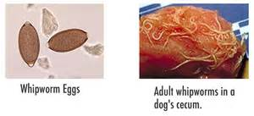
- Symptoms-
  - bloody diarrhea
  - painful or frequent defecation
  - abdominal pain
  - nausea
  - vomiting
  - headaches
  - sudden and unexpected weight loss
  - fecal incontinence, or the inability to control defecation
- Treatment:
  - Antiparasitic medication. Most people make a full recovery once treatment is received.
    - Ex. Albendazole and Mebendazole
- Prevention:
  - Avoid contact with soil that may be contaminated with human feces, including with human fecal matter ("night soil") used to fertilize crops.
  - Wash your hands with soap and warm water before handling food.
  - Teach children the importance of washing hands to prevent infection.
  - Wash, peel, or cook all raw vegetables and fruits before eating, particularly those that have been grown in soil that has been fertilized with manure
References
Center for Food Security & Public Health (CFSPH). (2005). Technical Fact Sheet: Trichuriasis
Retrieved from http://www.cfsph.iastate.edu/Factsheets/pdfs/trichuriasis.pdf

Global Health- Division of Parasitic Diseases and Malaria. (2016) Trichuriasis. Retrieved from
https://www.cdc.gov/dpdx/trichuriasis/index.html

SourSjlbdlfslljsjkdlkls

Parasitic Worms: Tapeworm

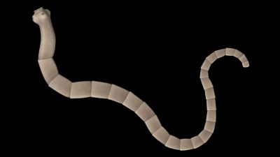
Echinococcus granulosus
Echinococcus multilocularis

Natural environment:
Echinococcus granulosus: Sheep raising areas, farms. Arizona, New Mexico; arid vast land with many reservoir hosts and potential for fecal contamination.

Echinococcus multilocularis: Forested areas where reservoirs live such as foxes and coyotes. High potential for fecal contamination.

Region where it can be found:
Echinococcus granulosus: Africa, Europe, Asia, the Middle East, Central and South America. U.S infected population mainly from immigrants where human cystic echinococcosi is endemic.

Echinococcus multilocularis: Northern latitudes. Central Europe, Russia, China, Central Asia, Japan, and North America. Montana to central Ohio, Alaska and Canada.

Reservoir:
Echinococcus granulosus: Sheep, pigs, livestock, but most commonly dogs
Echinococcus multilocularis: Foxes, coyotes, mainly dogs

Host Range:
Echinococcus granulosus: Nonhuman cases typically have the most broad most ranges, other than that, humans are definitive host, others are reservoirs such as listed above
Echinococcus multilocularis: Less broad, more commonly seen in wildlife creatures, humans are definitive species, others reservoir or paratenic hosts.

Predisposing & Occupational Risks:
Echinococcus granulosus: Uncontrolled dogs living closely with people, uncontrolled slaughter of livestock, unsanitary living conditions.
Echinococcus multilocularis: By directly ingesting food items contaminated with stool from foxes or coyotes. By petting or handling household dogs or cats infected with the Echinococcus multilocularis tapeworm. These pets may shed the tapeworm eggs in their stool, and their fur may be contaminated. Some dogs "scent roll" in foreign material (such as wild animal feces) and may become contaminated this way.
Disease:
Echinococcus granulosus: causes human cystic echinococcosi (CE)
Echinococcus multilocularis: casues alveolar echinococcosi in Europe (AE)
Infectious Dose:
Echinococcus granulosus: one worm
Echinococcus multilocularis: one worm

Mode of transmission:
Echinococcus granulosus:
-Fecal-oral, by ingesting food, water or soil contaminated with feces from infected dogs. Grass, herbs, greens, berries gathered from fields.
-By handling dogs infected with the Echinococcus granulosus tapeworm. Tapeworm eggs in stool, contaminated fur.
-"Hand-to-mouth" transfer.

Prevention as listed by the CDC:
“•Wash your hands with soap and warm water after handling dogs, and before handling food.
•Teach children the importance of washing hands to prevent infection.
•Avoid ingestion of food, water or soil contaminated with stool from dogs. This might include grass, herbs, greens, or berries gathered from fields.
•Don't allow your dogs to wander freely or to capture and eat raw meat from sheep, cattle, pigs, and goats.
•Don't home slaughter sheep and other livestock.
•If you think your pet may have eaten infected meat, consult your veterinarian about the possible need for preventive treatments.”

References:
Bogitsh, B. J., C. E. Carter, and T. N. Oeltmann. 2013. Human Parasitology, 4th edition.
Academic Press.

Dr.Russell Raymond, Pr

Global Health- Division of Parasitic Diseases. (2012). Alveolar Echinococcosis (AE) FAQs.
Retrieved from https://www.cdc.gov/parasites/echinococcosis/gen_info/ae-faqs.html

Global Health- Division of Parasitic Diseases. (2012). Cystic Echinococcosis (CE) FAQs.
Retrieved from https://www.cdc.gov/parasites/echinococcosis/gen_info/ce-faqs.html

Woolhouse, M. & Gowtage-Sequeria, S. (2005). Host Range and Emerging and Reemerging
Pathogens. Retrieved from https://wwwnc.cdc.gov/eid/article/11/12/05-0997_article

